* **Installation Minimalist GNU for Windows (MinGW) compiler**

**And setup**

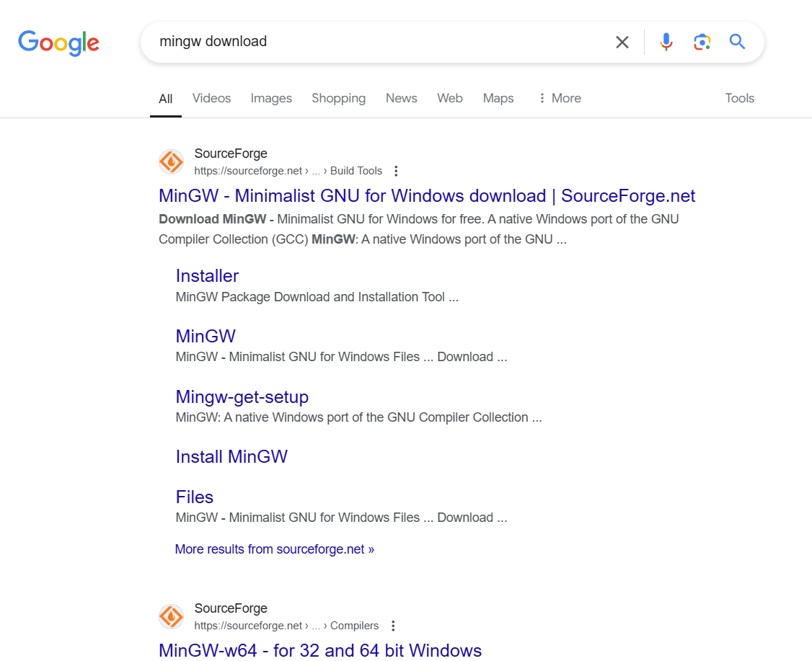

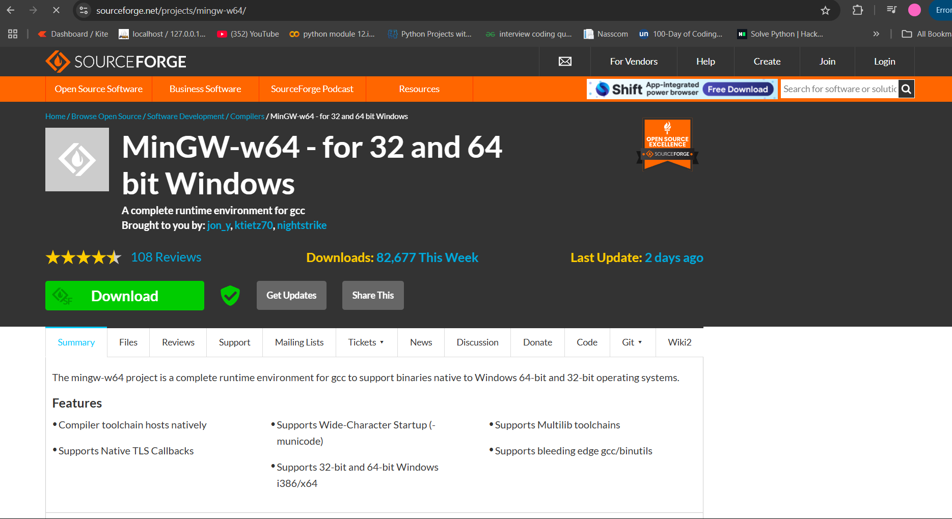

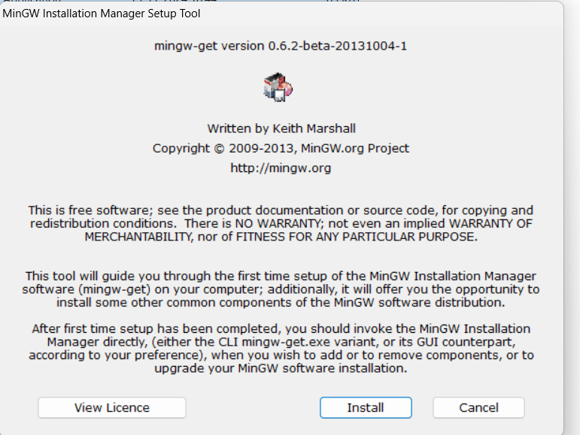

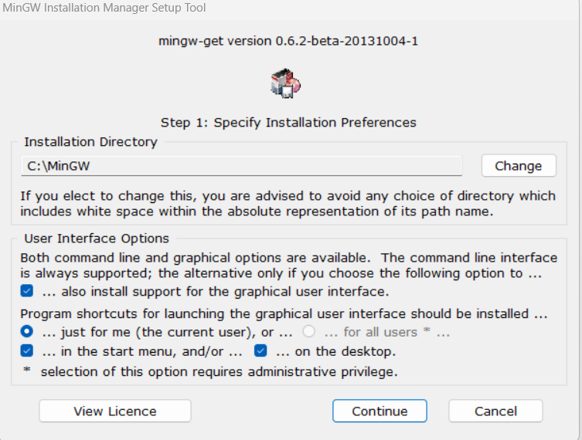

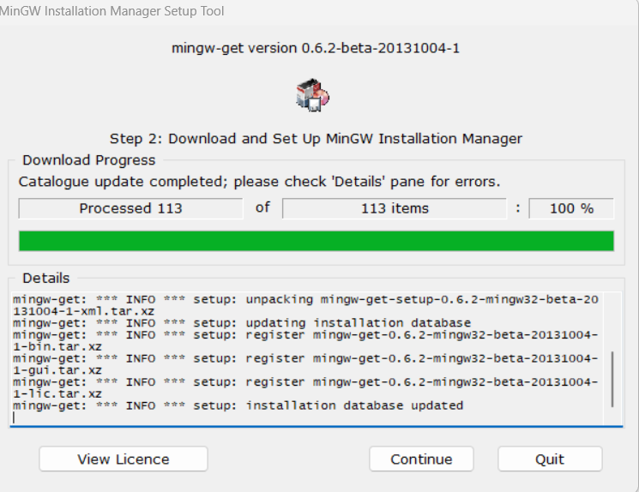

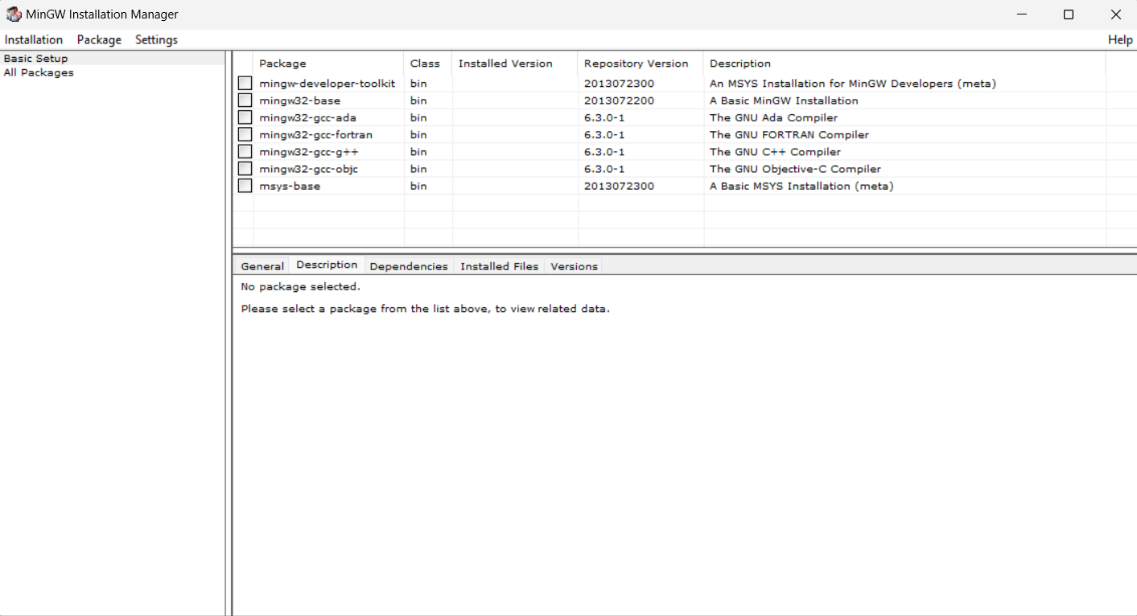

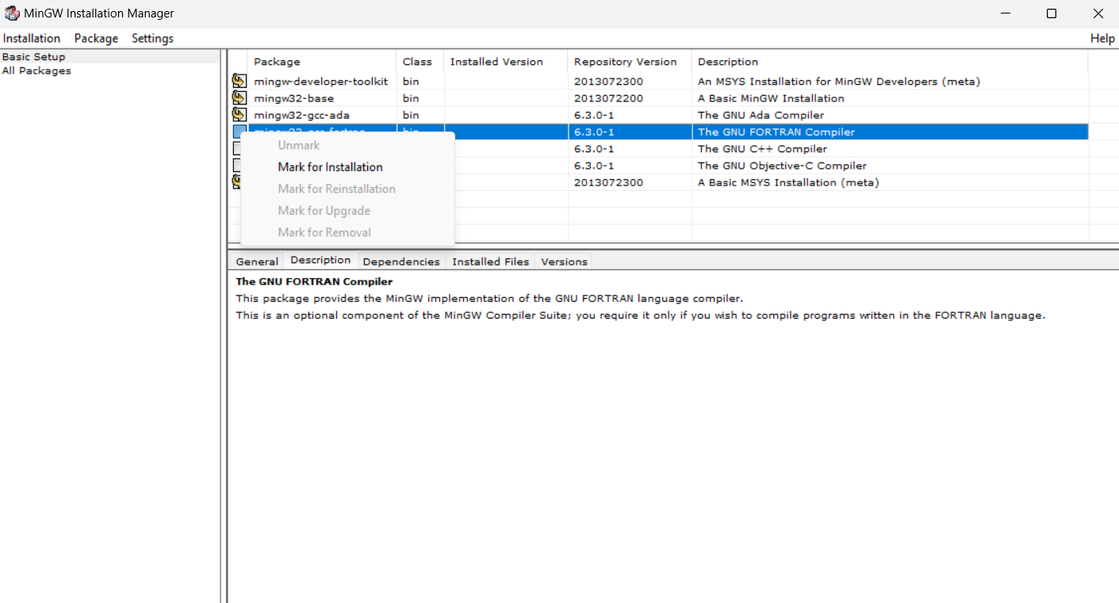

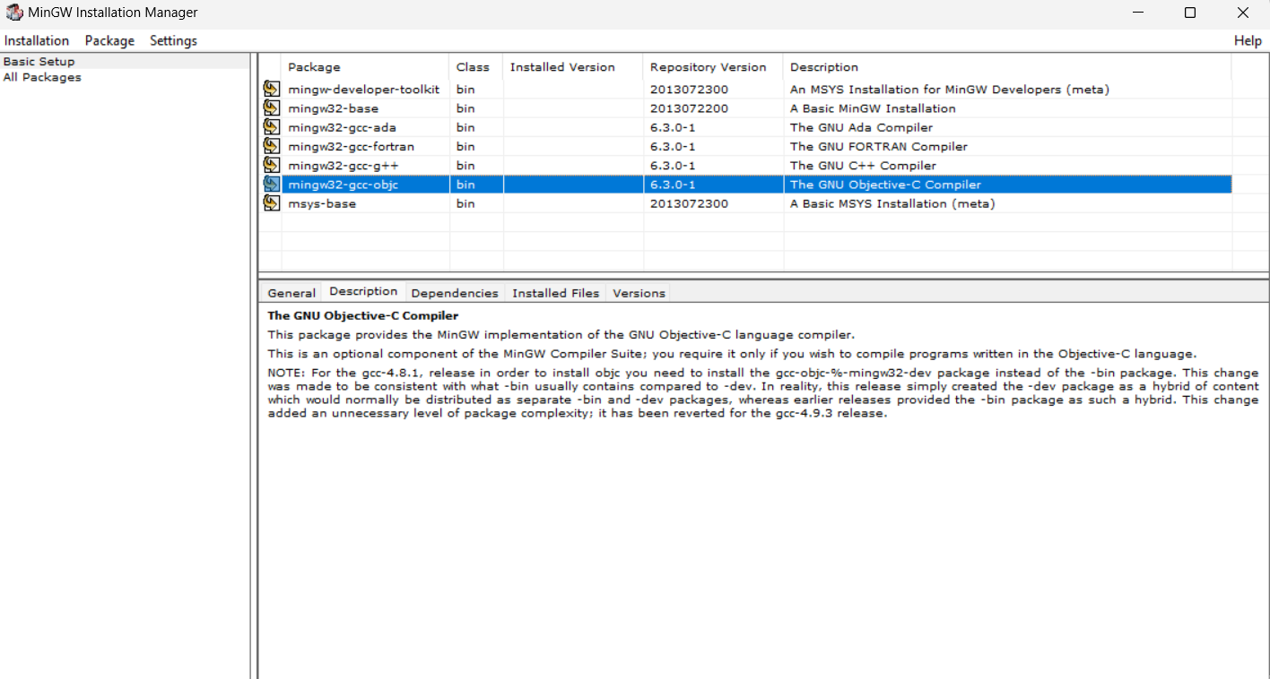

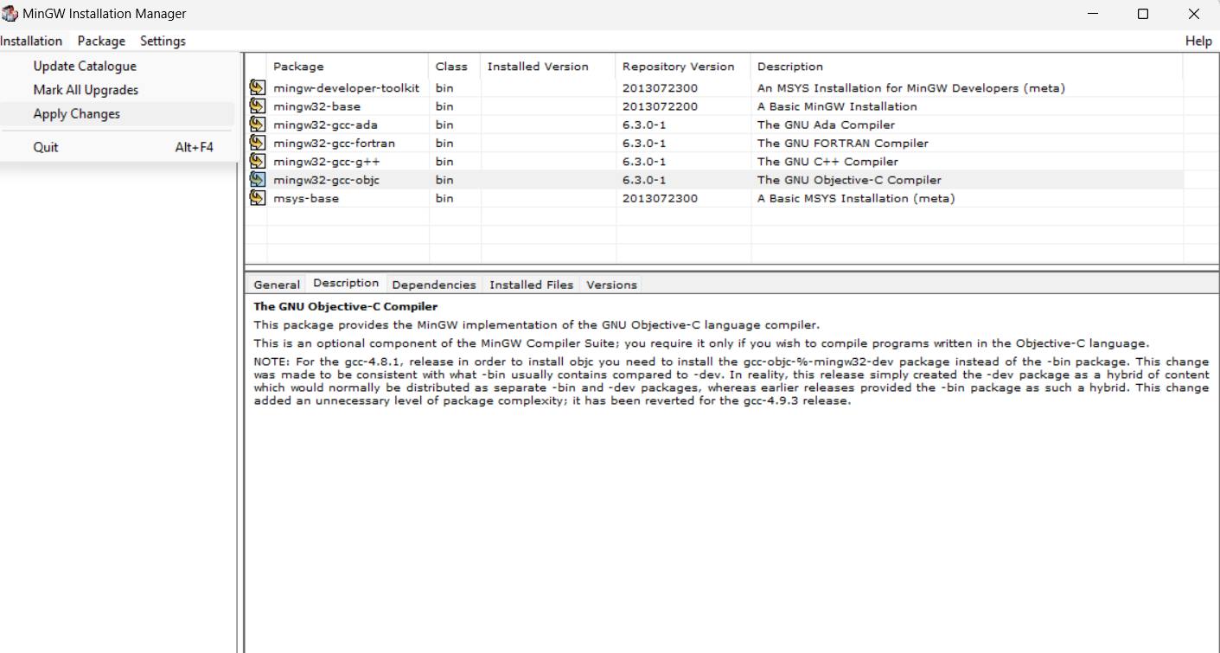

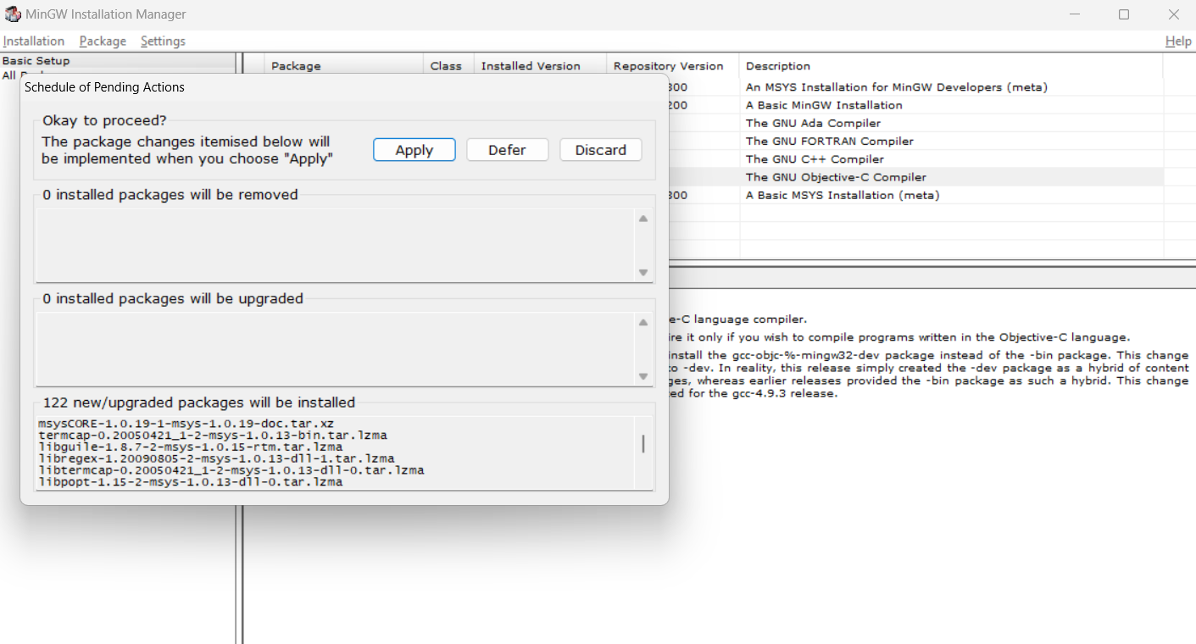

Now open the command prompt using **window+r**  here type **cmd**

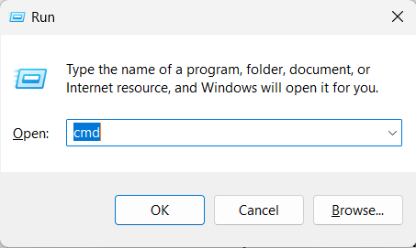

In command prompt type **gcc** or **g++** and press **enter**

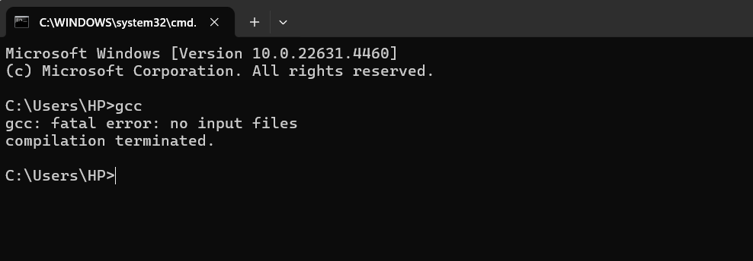

If its giving this output so your setup is done

Instead of this if the output is **gcc is not recognized in internal and external command** so follow this step :-

After installing minGW compiler . A folder will create in your pc inside the c disk

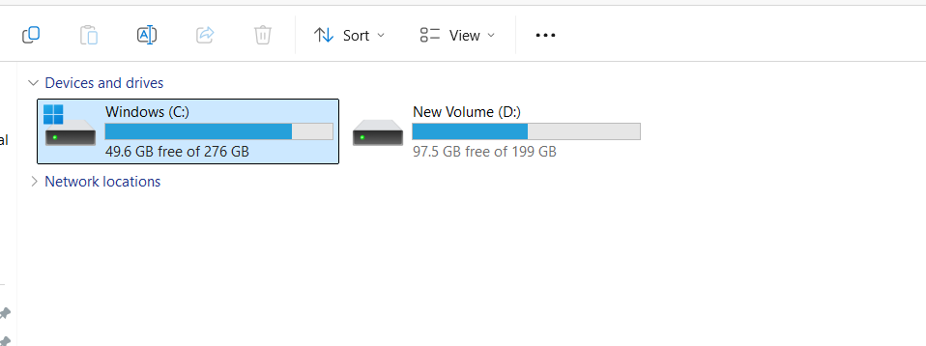

Open this folder

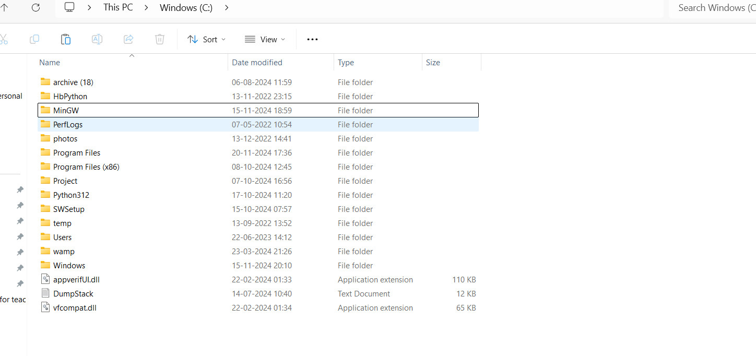

After that open this minGW folder

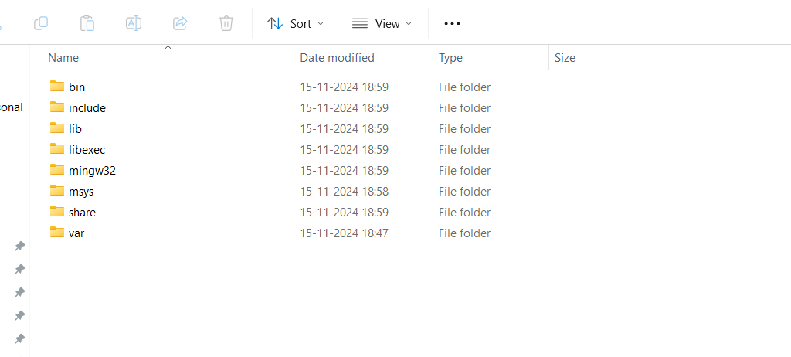

Open the bin folder

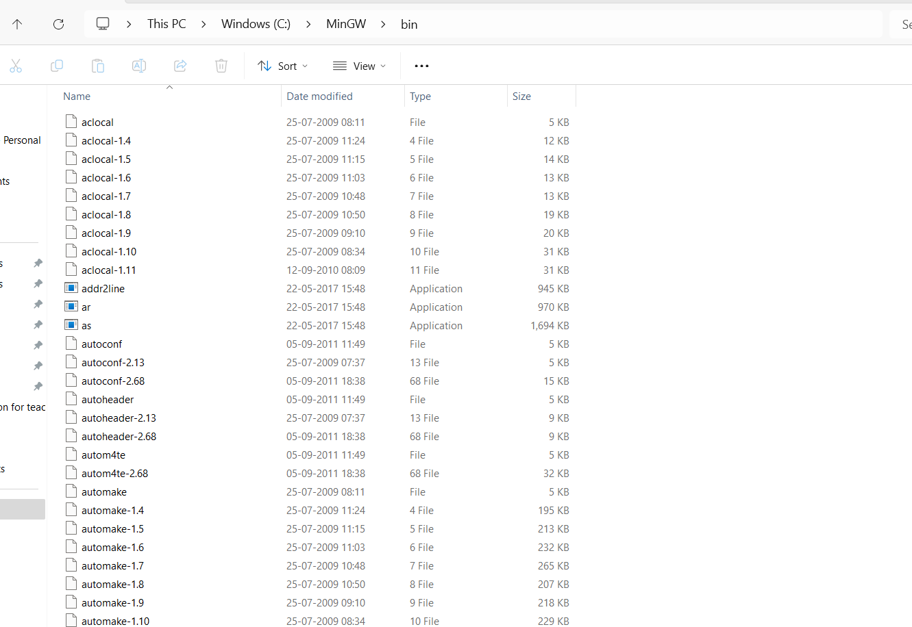

**C:\MinGW\bin** copy this path

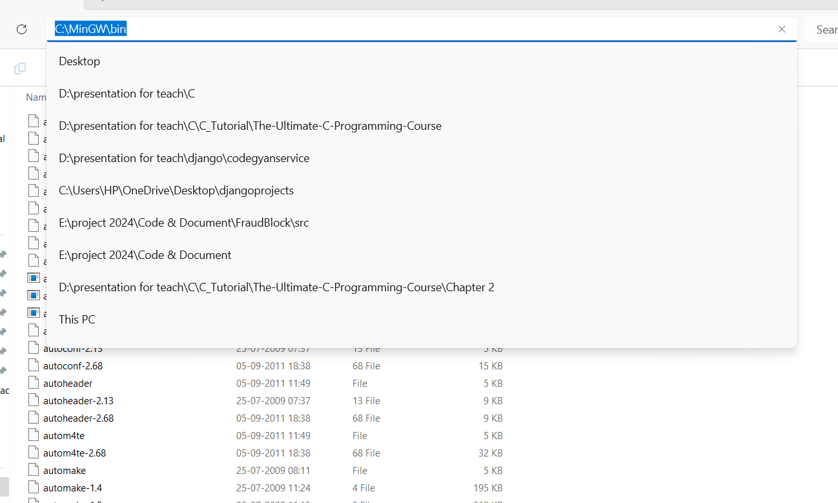

After copy this path open environment

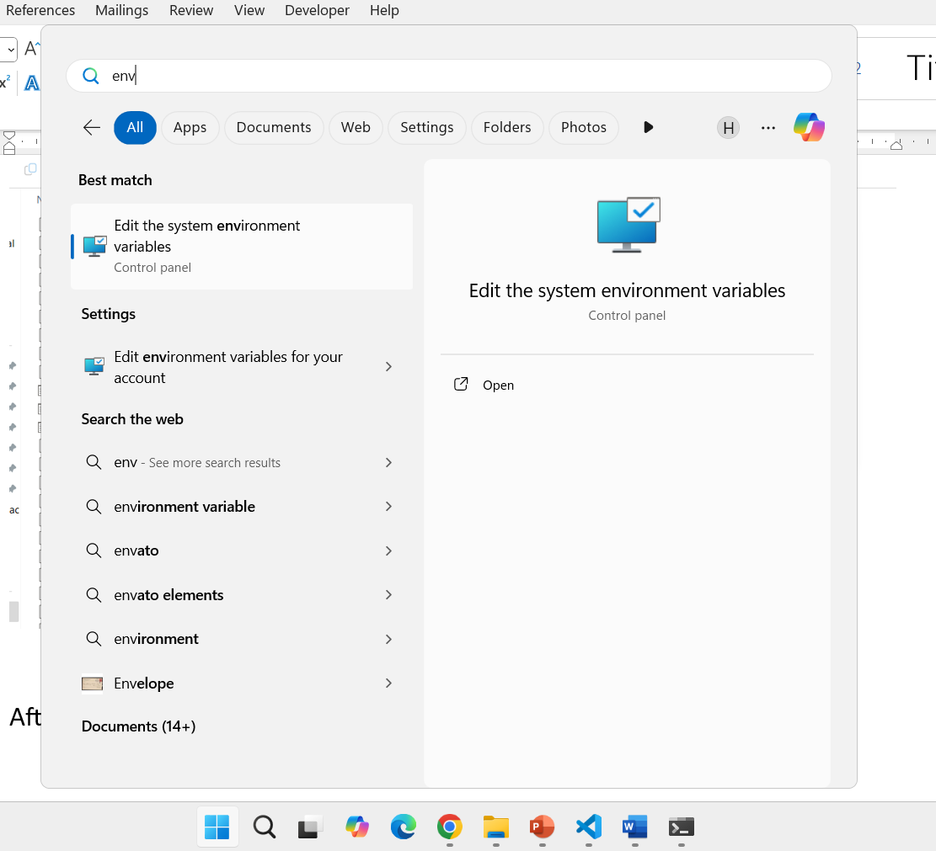

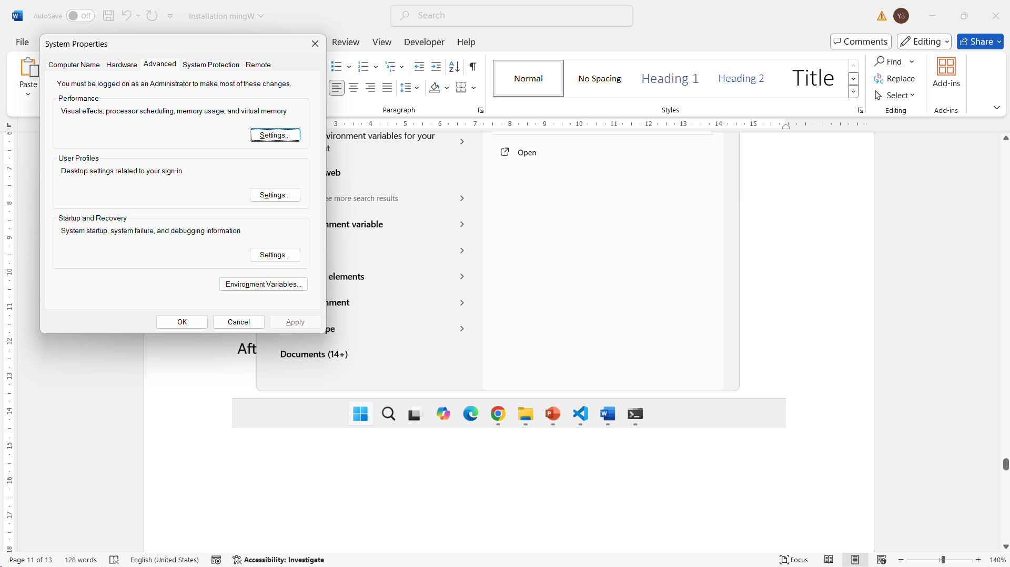



Then click on Environment Variables

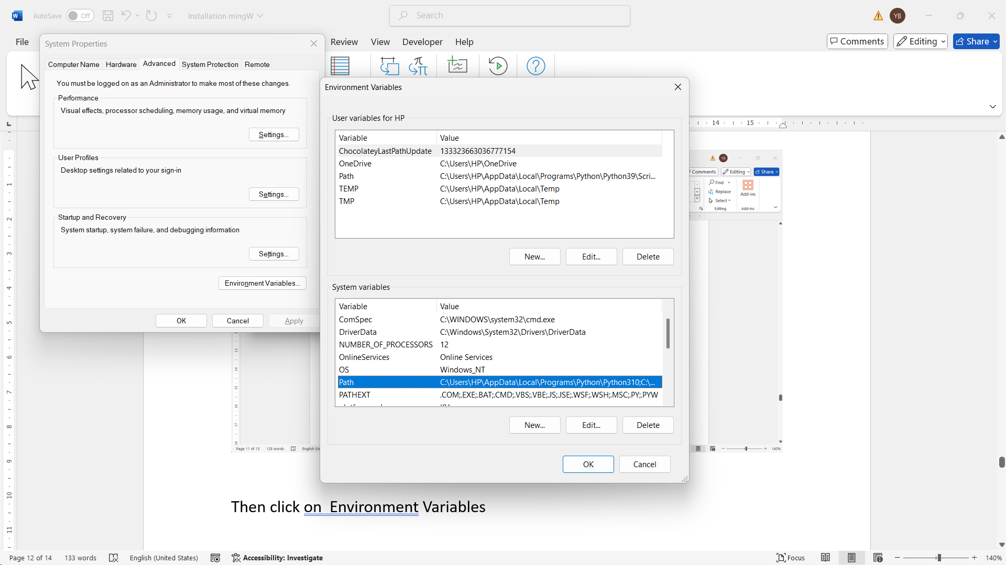

Then double click on the path

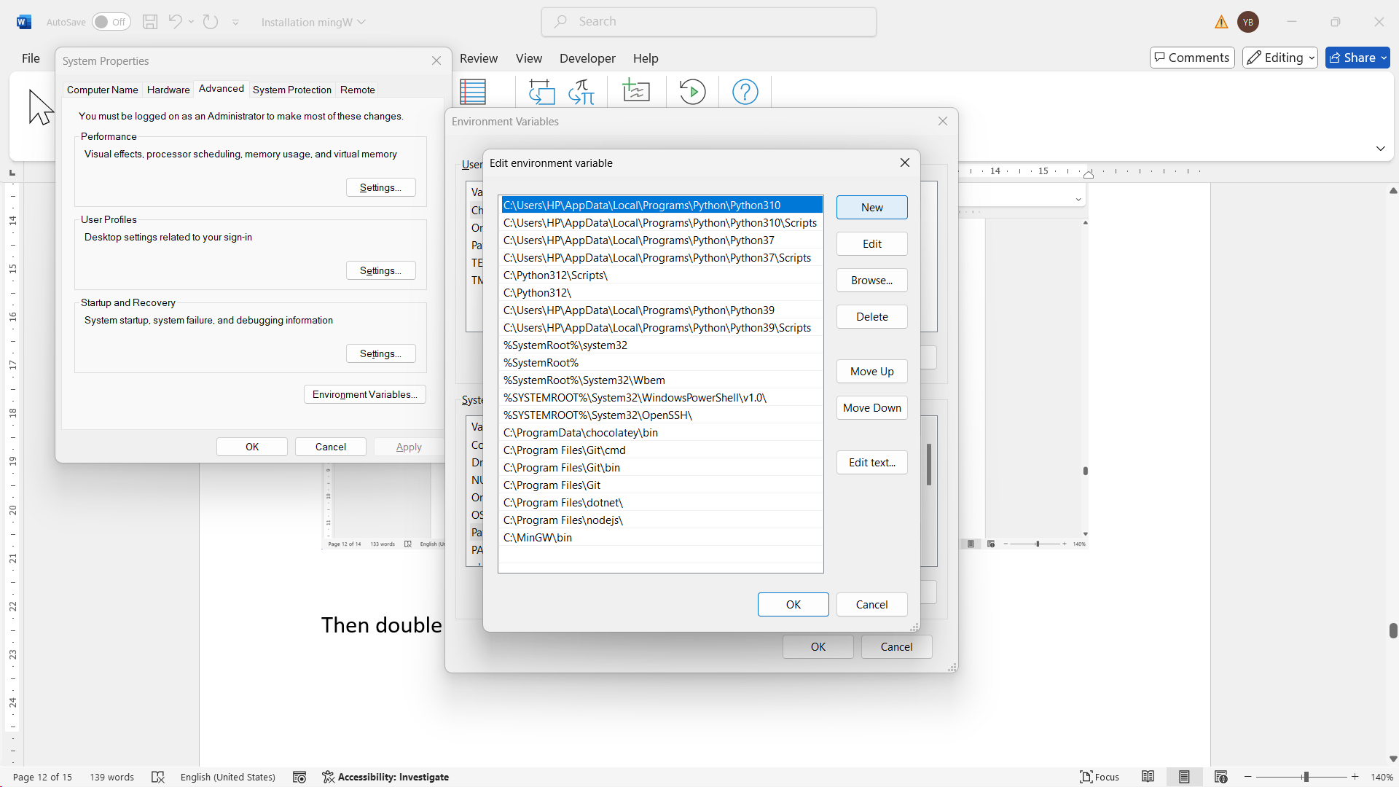

Here click on new and paste your file path using **ctrl+v**

After that click on ok ok and close all file after that open your command prompt and you can check using **gcc** command

Here your compiler setup is done now you can run your c code

Now install vs code for writing the code after installing vs code

install extension **c/c++** in vs code

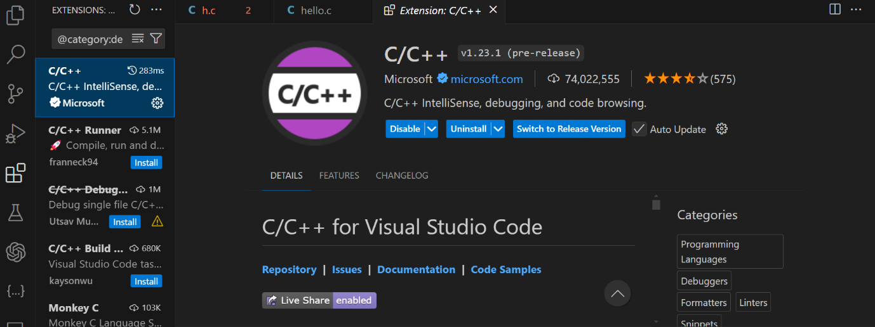

After that write the code and open terminal

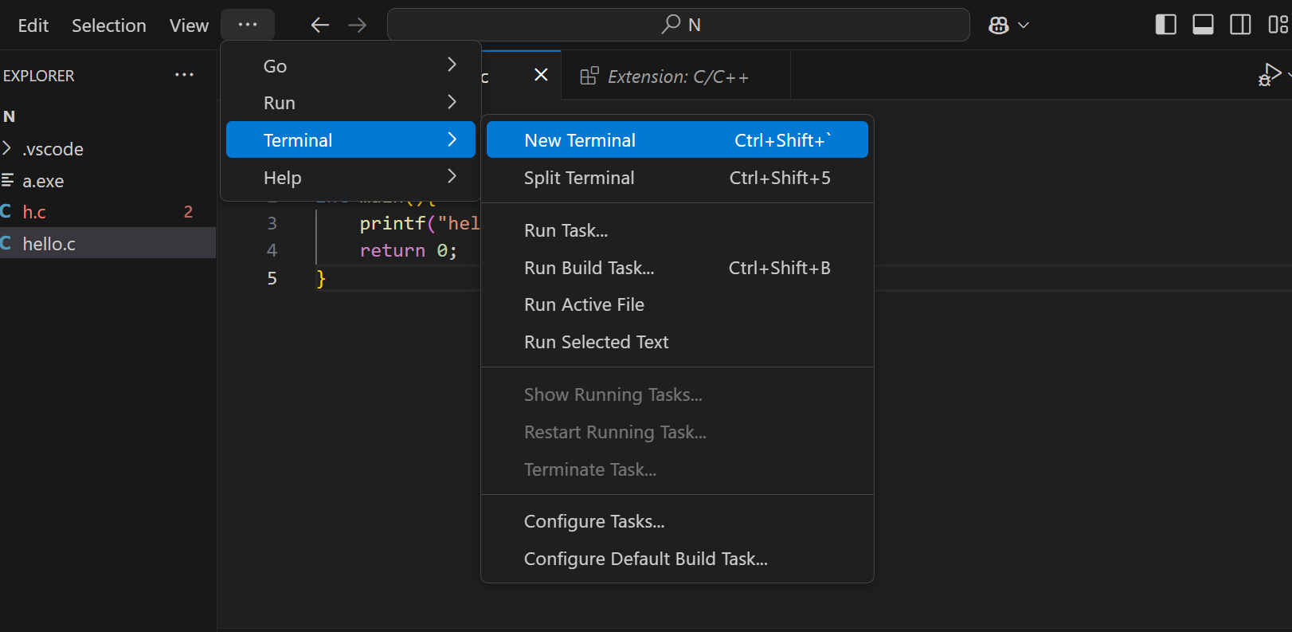

Then run using this command in the same location  
 **gcc hello.c**

**./a.exe**

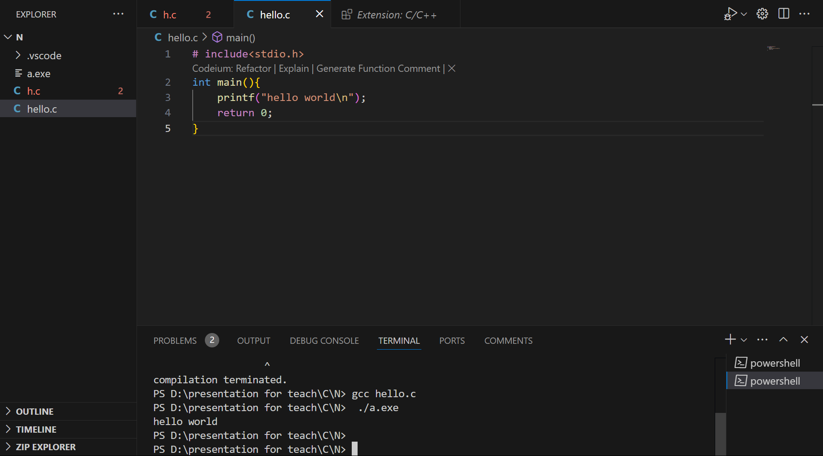

For mac   
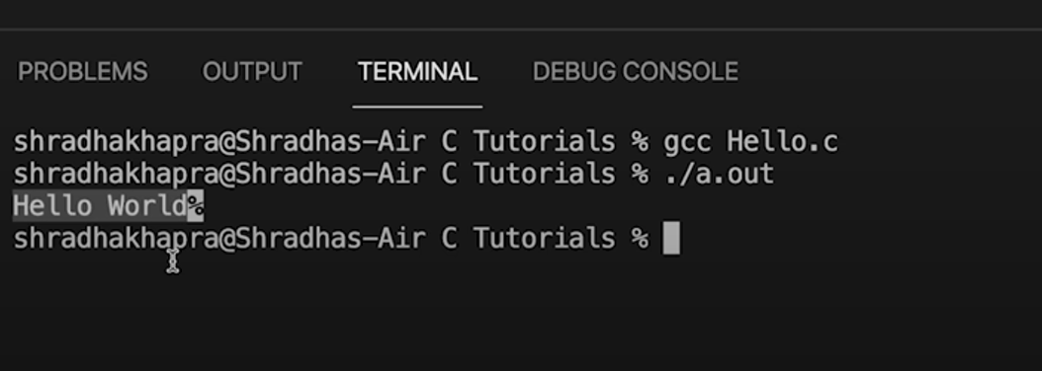

Use this command.